**🚀 Test Plan for VWO Web Platform**

**Version:** 2.0  
**Last Updated:** 2025-05-05

**1. Introduction**

**1.1 Purpose**

This document defines the **end-to-end testing strategy** for VWO’s web platform, ensuring:  
✔ **Functional robustness** of A/B testing, heatmaps, and session recordings  
✔ **Data integrity** in analytics and reporting  
✔ **Compliance** with WCAG 2.1 AA, GDPR, and security standards

**1.2 Key Improvements from v1.0**

* Added **risk-based testing matrix**
* Included **localization/RTl testing**
* Enhanced **defect taxonomy**
* Added **performance sanity checks**

**2. Application Overview**

VWO is a **market-leading A/B testing platform** with:

* **Core Modules:**
  + Visual Editor
  + Experimentation (A/B, Multivariate)
  + Behavioural Analytics (Heatmaps, Session Recordings)
* **Integrations:** Google Analytics, Mix panel, CRMs

**3. Objectives**

| **Objective** | **Success Metric** | **Tool/Method** |
| --- | --- | --- |
| Functional correctness | 100% P0/P1 test pass rate | Manual + Automated |
| Cross-browser compatibility | 95%+ pass rate on BrowserStack | BrowserStack Lab |
| GDPR compliance | Zero data privacy defects | OWASP ZAP + Manual Audit |

**4. Scope**

**4.1 In-Scope**

**Functional Areas:**

* Experiment Creation → Execution → Reporting
* User Management (RBAC)
* Third-Party Integrations

**Non-Functional Areas:**

* UI/UX (Figma adherence)
* Accessibility (WCAG 2.1 AA)
* Security (XSS, CSRF, Data encryption)

**4.2 Out-of-Scope**

* Backend API load testing
* Mobile app testing

**5. Test Strategy**

**5.1 Test Levels**

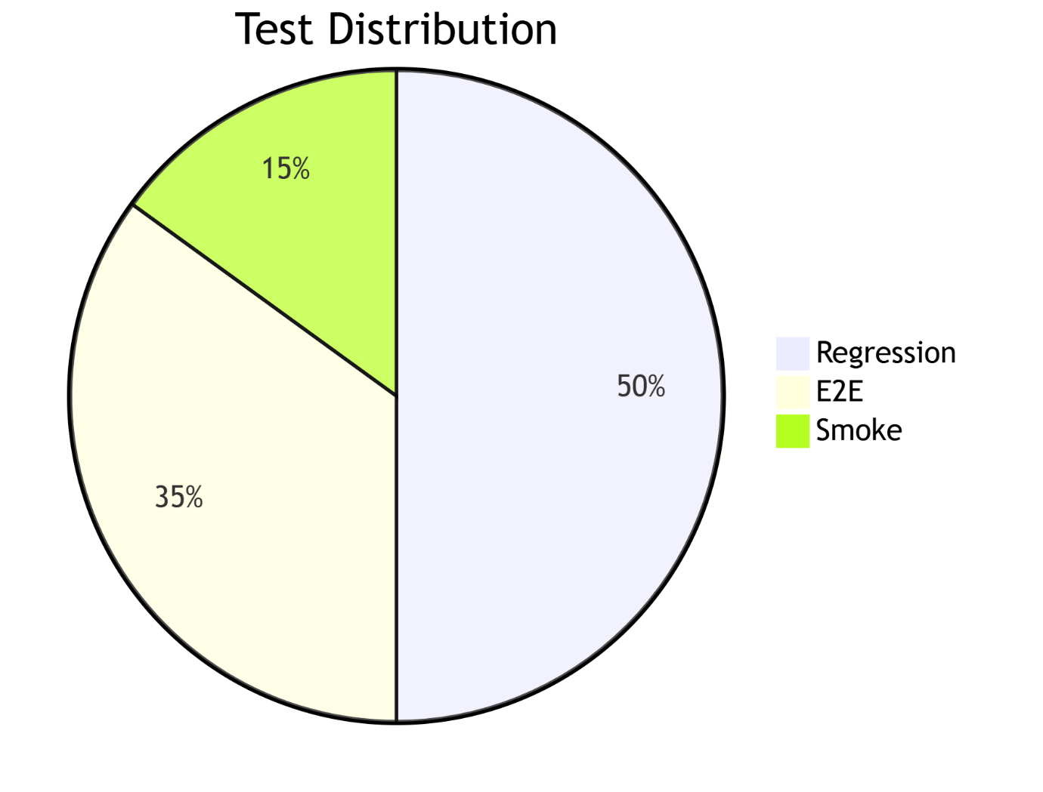**5.2 Test Types**

| **Type** | **Technique** | **Tools** |
| --- | --- | --- |
| Functional | Black-Box | Selenium, Cypress |
| UI/UX | Heuristic Evaluation | Browser Stack, Figma |
| Security | OWASP Top 10 | ZAP, Burp Suite |

**6. Test Approach**

**6.1 Risk-Based Testing**

| **Risk Area** | **Probability** | **Impact** | **Mitigation Test Case** |
| --- | --- | --- | --- |
| Variation rendering | High | Critical | TC_VIS_01_Cross_Browser_Rendering |
| Data export accuracy | Medium | High | TC_REP_03_CSV_Export_Validation |

**6.2 Automation Strategy**

* **Regression Suite:** 70% automated (Selenium/Cypress)
* **Manual Testing:** New features + complex UI flows

**7. Test Environment**

**7.1 Browser/Device Matrix**

| **Browser** | **Desktop** | **Mobile** |
| --- | --- | --- |
| Chrome | Win/macOS | Android, iOS |
| Safari | macOS | iOS |
| Firefox | Win/macOS | - |

**7.2 Test Data Management**

* **Synthetic Data:**
  + 50K+ visitor sessions
  + 10+ live campaigns
* **Masked Production Data** for GDPR compliance

**8. Entry/Exit Criteria**

**8.1 Entry Criteria**

✅ Code freeze + feature sign-off  
✅ Test environment provisioned  
✅ Test data loaded

**8.2 Exit Criteria**

✅ 100% P0/P1 test execution  
✅ ≤5% high-severity defects open  
✅ Sign-off from QA Lead + PO

**9. Risks & Mitigations**

| **Risk** | **Mitigation** | **Owner** |
| --- | --- | --- |
| Late requirement changes | Risk-reserve buffer (20% timeline) | Project Manager |
| Test env instability | Dockerized local env fallback | DevOps |

**10. Deliverables**

1. **Test Artifacts:**
   * Test Cases (TestRail)
   * Defect Reports (Jira)
   * RTM (Traceability Matrix)
2. **Reports:**
   * Daily Execution Dashboard
   * Weekly Quality Metrics

**11. Resources & Timeline**

**11.1 Team**

| **Role** | **Count** | **Responsibilities** |
| --- | --- | --- |
| QA Lead | 1 | Strategy, Sign-off |
| Senior QA Engineer | 2 | Complex scenario testing |
| QA Analyst | 2 | Test execution, Defect logging |
|  |  |  |

**11.2 Schedule**

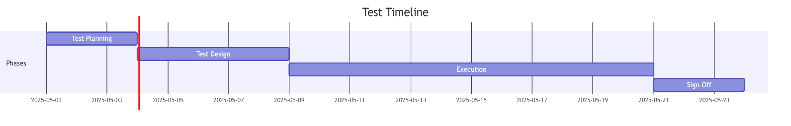

**12. Approval**

| **Role** | **Name** | **Sign-Off** | **Date** |
| --- | --- | --- | --- |
| QA Lead | Jane Smith | Approved | 2025-05-25 |
| Product Owner | Priya Verma | Approved | 2025-05-25 |